The Millennial Gap
Bridging the generaion gap within the church has been a constant battle for years. Each generation voices complaints, regarding the tone, style, and opportunities available in the church, during their adolescent years. Today’s young adult generation, known as millennial, is a decreasing demographic in the church. A survey conducted by Rachel Held Evans suggests, “young adults perceive evangelical Christianity to be too political, too exclusive, old-fashioned, unconcerned with social justice and hostile to lesbian, gay, bisexual and transgender people.” (Evans, 2013) These thought patterns might be a result of lackadaisical ministering by evangelical leaders. Evangelical leaders are often focused on making “a few style updates – edgier music, more casual services, a coffee shop in the fellowship hall, a pastor who wears skinny jeans, an updated Web site that includes online giving”(Evan, 2013), to appeal to younger audiences. Many ignore opportunities to engage youth and question their struggles in life and their expectations of the church.
How do we promote civic participation and continued spiritual growth among the millennial generation? To answer this question one must first look at the reasons they are leaving the church. Hemant Mehta attributes decreasing participation to widely accessible information available on the Internet. Mehta states, “Christians can no longer hide in a bubble, sheltered from opposing perspectives, and church leaders can't protect young people from finding information that contradicts traditional beliefs.” (Mehta, 2013) As more information is made available daily young adults familiar with Google and other well-known sites opt to answer queries online opposed to face-to-face meetings with a pastor. Mehta also explains, “Atheists outnumber Christians on popular discussion forums like Reddit, where subscribers to the atheism section number more than 2 million.” Having a high volume online presence enables nonbelievers to reach the millennial generation quicker and on a constant basis, with little Christian rebuttal.
As previously mentioned, common criticism of the church by young adults stem from the traditional values proposed by the church. A 2012 study by the Public Religion Research Institute (PDF) indicated that many Christians between the ages of 18 and 24 expressed opinions describing Christianity as hypocritical (49%), judgmental (54%) and anti-gay (58%). With opinions of this magnitude many anti-Christian groups have the artillery available to discourage prospective and current millennial Christians. To counteract this trend of decreasing members one can look to two communication theories: The Rhetoric and Uses and Gratification.
Rhetorical Theory
Aristotle is the originator of Rhetorical Theory, which is the theoretical foundation of public speaking. One is capable of persuading the masses during a public speech by encompassing three rhetorical proofs: logos, pathos, and ethos. (West & Lynn, 2003) Logos is the logical proof and evidence used in a speech to persuade audiences. (West & Lynn, 2003) This includes statistics, survey results, and historical facts, etc. Pathos is the use of emotions to draw an emotional reaction from audience (e.g. fear, joy, or anger). (West & Lynn, 2003) Ethos is “the perceived character, intelligence, and goodwill of a speaker as they become revealed through his or her speech.”(West & Lynn, 2003, pg. 314)
Rhetorical Theory has passed the heuristic test multiple times, serving as the foundation of current research studies. A study in Papua New Guinea used rhetoric as a means to explain how “the Kaluli people rapidly embraced evangelical Christianity…[and made] substantial changes in cultural orientation, new social divisions, and a progressive reorganization of the society around the church.” (Schieffelin, 1981, pg. 150) Researchers explained how pathos was used during pastors’ sermons to persuade the Kaluli people to adopt Christianity as their own religion. By prophesying the coming of the Judgment Day pastors convinced citizens to abandon their beliefs, setting in motion the restructuring of their society. (Schieffelin, 1981)
Researchers examined the use of rhetoric in arguments in the Supreme Court case Employment Division v. Smith. Religious leaders dissuaded the passing of Smith law, which would allot the government power to threaten religious liberties. The appropriateness of a minor’s consumption of communion in the Catholic Church was compared to the use of peyote in Native American rituals, which mobilized sympathy among readers. Audiences were asked to imagine themselves in a similar situation that would allow the “government to [deny their] children the opportunity to participate in [their] religious ceremony.” (Tushnet, 1993, pg. 120) The pathos and ethos exhibited in this case aided in the dismissal of Smith law.
According to Bizzell, a “large degree [of] existing research on rhetoric represented a single, very traditional "rhetorical tradition”, which pretty much excluded women, people of color, and any one without an elite education.” (Bizzell, 1992, pg. 50) A study was then formed to highlight works representing African Americans and their rhetorical contributions to the literature of speech communication. (Rigsby, 1993) Rigsby began by acknowledging the lack of published research illustrating the use of rhetoric in the African American community, prior to Brown v. Board of Education. Following the well-known case, protests and bus boycotts erupted with rhetoric strategies at its foundation. (Rigsby, 1993) Martin Luther King Jr. started his career as spokesperson for Civil Rights and used rhetoric proofs as a means to reach numerous congregations.
African American women have also demonstrated rhetorical competency as a means for reaching massive congregations. Campbell uses fractions of historical speeches to illustrate African American women’s contribution to rhetorical speech. Campbell begins initially with Sojourner Truth’s proclivity for civic participation, and the spreading of her perception of God and the Christian faith. (Campbell, 1986) With such a historical background Truth was able to relate to woman’s suffrage and use strategies of rhetoric to appeal to white feminists. Truth’s powerful use of metaphors cultivated and raised awareness of audiences (Campbell, 1986), which paved the way for future feminist leaders. Others mentioned in “Style and content in the rhetoric of early Afro‐American” were Ida B. Wells and Mary Church Terrell. Wells made substantiated arguments devoid of feminine stylistic traits, while Terrell adopted a womanly style, both ideal for developing identification between white audiences and themselves. (Campbell, 1986)
Many strategies mentioned can aid modern day churches in the fight for inspiring and maintaining participation among millennial members in the church.
Uses and Gratification Theory
Uses and Gratification Theory suggests audiences purposely select specific media to satisfy particular needs. (Katz et al, 1973) Studies, acknowledging the existing relationship between churches and media use, disclose that newspaper readers (as opposed to television viewers) partake in religious activities on a regular basis. (Nyland &Near, 2007) The same has been conveyed for Internet users, as approximately 82 million users satisfy religious and/or spiritual needs online. (Hoover et. al., 2004) “Religious online users [use] the Internet for purposes such as sending and receiving emails, receiving and sending online greeting cards, learning about religious events and affairs, information about religious holidays, and finally information on where they could attend religious services.” (Nyland &Near, 2007, pg. 8)
As church goers have many uses for the Internet, what needs does the church satisfy for those media users? To answer this, one must first look at the relationship between media and the religious institution. "Today, media influences religion to the point where institutional strategies in religion are based on the forms of modern media. Consequently, religion is now part of a media culture and operates to a large extent through media logic." (Altheide & Snow, 1979, pg. 200 & Pettersson, 1986) People turn to church to satisfy certain needs similar to those who turn to television. As mass communication affects the religious realm the avenues for gratification are also altered.
A study, by Thorleif Pettersson, relates Uses and Gratification Theory to TV church viewers in the Swedish community. Pettersson attempts to answer, "Is viewing TV worship services functionally similar to attending church?" and "Is viewing TV worship services less burdensome than attending church?” (Pettersson, 1986, pg. 392) Answering the latter, “About eight respondents out of ten indicated "easiness" as the primary advantage of watching TV service” opposed to better sermons or music. (Pettersson, 1986, pg. 396) To answer the former, researchers determined the levels of gratification from church service attendance. Researchers found that majority of respondents gained the same amount of gratification from TV views and actual attendance. (Pettersson, 1986) This outcome led researchers to assume some variations exist in the kinds of gratification between each mode of worship.
Researchers combined gratification typologies from mass media use and behavioral sciences of religion to create gratifications for church attendance. The researcher’s typology of gratifications from mass media use is three-dimensional: “Which relations (cognitive, affective, integrative, etc.) to which referents (self, family, neighborhood, tradition, society, etc.) are affected in which way (strengthened, acquired, and weakened) by mass media use?” (Pettersson, 1986, pg. 398) Typologies are then viewed from a religious and nonreligious point of view. Pettersson’s Typologies Pictured Below:
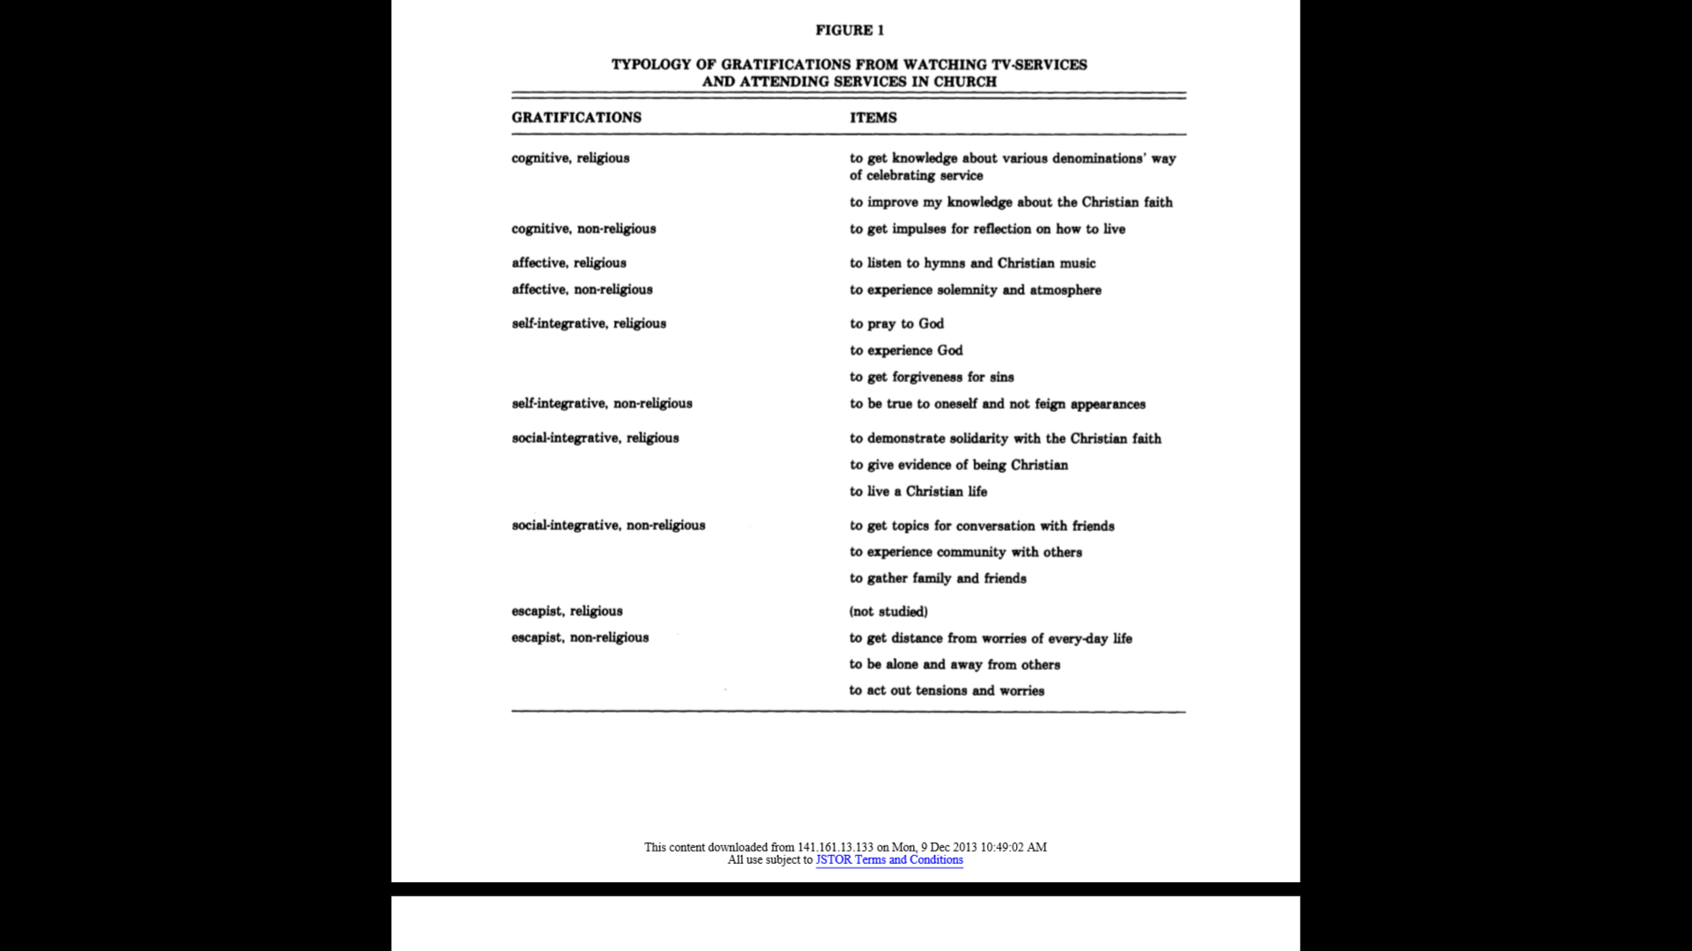
Understanding the gratifications acquired from viewing TV church services and actual attendance can aid evangelical leaders in their mission to inspire and maintain participation amongst the millennial generation.
Conclusion: Why Rhetoric Theory and Uses and Gratification Theory?
Rhetorical Theory and Uses and Gratification Theory were selected to address the phenomenon; lack of church attendance and participation by the millennial generation. Rhetorical Theory, being fundamentally the foundation of public speech and persuasion, is ideal for evangelical ministries because the information retrieved by church visitors primarily derived from the preacher’s sermon.
Furthermore, a primary assumption associated with Rhetoric Theory is, “Effective public speakers must consider their audience.” (West & Lynn, 2003, pg. 313) To bridge the gap between the millennial generation and the church, preachers must understand the viewpoint of that demographic. Understanding the issues, desires and expectations of the young adults would equip evangelical leaders with the tools necessary for persuasion.
Once evangelical leaders have determined the issues, desires, and expectations of the millennial generation the elements of the church can be altered so this gap can be eliminated. Recent research in Uses and Gratification Theory supports the understanding that church participants use church as a source of gratification. One undertaking for evangelical leaders should be determining the reasons behind coming to church, among this generation. While the previous statement is not a new consideration, once these gratifications have been explored communication practices can begin to encourage participation in the millennial generation.
These theories are unhelpful in determining best use of media to communicate with the millennial generation. However, Rhetoric Theory does offer different forms of rhetoric to address audiences. A speaker can choose between forensic, epideictic, and deliberative for persuading audiences. Selecting a method of persuasion can be costly if done incorrectly. The millennial generation is quite informed. Thus, with social media on the rise, they have access to an abundance of information and the means to communicate globally. However, with Uses and Gratification Theory and Rhetoric Theory, evangelical leaders are able to inspire participation among current millennial members and attract prospective members within the community.
Ah! But is this the main purpose of the church, gratification of the human or the spirit?
Resources
Altheide, David and Robert Snow 1979 Media Logic. London: Sage.
Bethke J., The new religious fundamentalists? Millennial Christians., The Washington Post, 2013. http://www.washingtonpost.com/blogs/on-faith/wp/2013/08/08/the-new-religious-fundamentalists-millennial-christians/
Bizzell, P. (1992). Opportunities for feminist research in the history of rhetoric. Rhetoric Review, 11(1), 50-58.
Burns, J., Getting Kids Involved at Church, Christian Broadcasting Network, 2013. http://www.cbn.com/family/parenting/getting-kids-involved-at-church-burns.aspx
Campbell, K. K. (1986). Style and content in the rhetoric of early Afro‐American feminists. Quarterly Journal of Speech, 72(4), 434-445.
Chandler, A. S. (2004). Exploring cross-generational attitudes and opinions on the use of multimedia in the Christian Church (Doctoral dissertation, University of Florida).
Evans, R. H., Why millennials are leaving the church, CNN, 2013. http://religion.blogs.cnn.com/2013/07/27/why-millennials-are-leaving-the-church/
Hoover, S., Clark L., & Rainie L. (2004). Faith Online: 64% of wired Americans have used the Internet for spiritual or religious purposes. Retrieved October 18, 2006 from ProQuest database.
Katz, Elihu, Michael Gurevitch, and Hadassah Haas 1973 "On the use of mass media for important things." American Sociological Review 38: 164-81
Marshall T., 80% Catholic Youth Leave the Church (and how to fix it), Taylor Marshall, 2013. http://taylormarshall.com/2013/09/80-catholic-youth-leave-the-church.html
Mehta H., Why are millennials leaving church? Try atheism, CNN, 2013. http://religion.blogs.cnn.com/2013/07/30/why-are-millennials-leaving-church-try-atheism/
Nyland, R., & Near, C. (2007, February). Jesus is my friend: Religiosity as a mediating factor in Internet social networking use. In AEJMC Midwinter Conference, Reno, NV.
Pettersson, T. (1986). The audiences' uses and gratifications of TV worship services. Journal for the Scientific Study of Religion, 391-409.
Rigsby, E. D. (1993). African American rhetoric and the ‘profession’. Western Journal of Communication (includes Communication Reports), 57(2), 191-199.
Schieffelin, EL. 1981. Evangelical rhetoric and the transformation of traditional culture in Papua New Guinea, Comparative studies in society and history,23(1), 150. (ISSN: 0010-4175).
Tushnet, M. (1993). Rhetoric of Free Exercise Discourse, The. BYU L. Rev., 117.
West, T., & Turner, L. (2003). Introducing communication theory: analysis and application with powerweb.

